LAB # 12
EXCEPTION HANDLING
OBJECTIVE:
Constructing a fault tolerant program by implementing exception handling techniques.
LAB TASK 01 :
CODE :
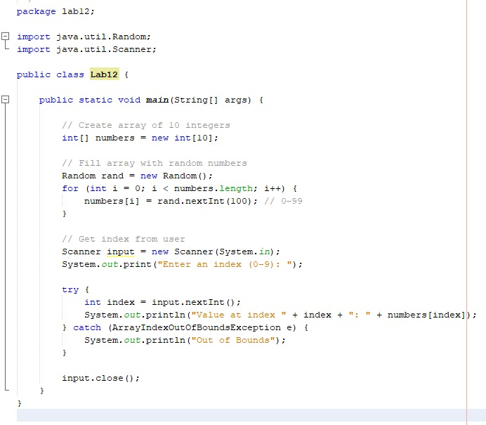
OUTPUT :
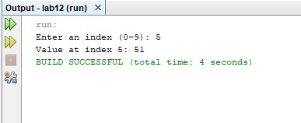

LAB TASK 02 :
CODE :
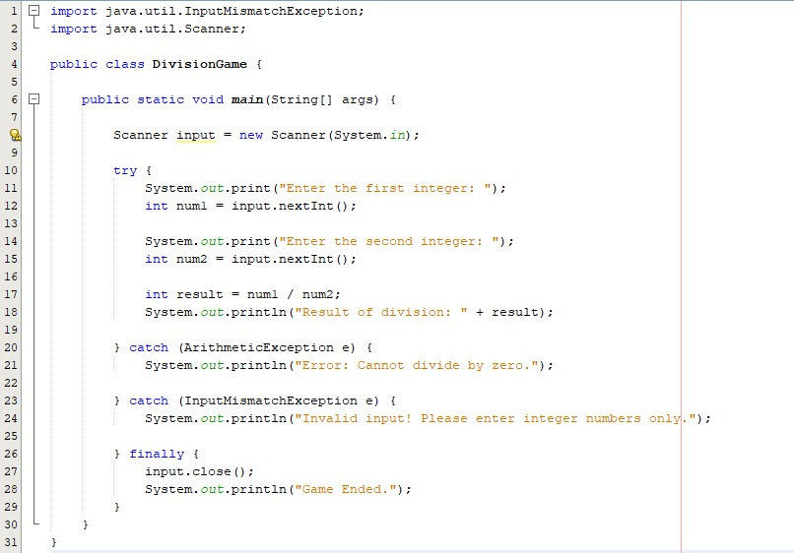

OUTPUT :
